REPLACE WITH YOUR MASTHEAD
 | SOG Title:
 | SOG Number:
 | Original Date: | Revision Date:

ABC Fire Department General Operating Guideline

Surge Protection Devices

Protecting Sensitive Electrical Equipment

This is a sample of a standard operating guideline (SOG) on this topic. You should review the content, modify as appropriate for your organization, have it reviewed by your leadership team and if appropriate your legal counsel. Once adopted, make sure the SOG is communicated to members, implemented and performance monitored for effective implementation.

Purpose:
The purpose of this guideline is to understand the need for and application/use of surge protection devices to protect sensitive electrical equipment.

Background:
The rapid advancements that have been made in computers and related technology have not only changed everyday life, but the tools, communication systems and response capabilities of emergency service organizations (ESOs). Today’s ESO stations mirror modern office environments - networked computers, printers, servers, complex phone and voice/data systems, copiers and conference/training rooms with high-tech audio/visual equipment. Communication and dispatch centers are now equipped with computer-aided dispatch systems with GIS mapping, GPS tracking and satellite/cable feeds for news and weather monitoring to supplement the radio equipment and other communication systems. Important records and information that used to be kept in file cabinets are now kept on computers and servers that may also record voice data from phones and radio communications.

The downside: these improvements increase an ESO’s reliance on this sensitive electrical equipment. The circuit boards, microprocessors and computer chips in modern equipment rely on stable power systems. This reliance increases the potential for a serious loss of communication, response capability and/or data in the matter of the millisecond that it takes for an electrical surge to hit and damage or destroy sensitive electrical equipment. Many ESOs have an emergency generator to handle power loss problems; however, without the proper controls to prevent or mitigate damage from power surges, an emergency power supply is of limited use since it will not restore damaged equipment. It will only get what has survived back up and running. Even then, undetected damage may have occurred, weakening equipment and making premature failure more likely.

Procedure:
Surge Exposures
Most people think of surge losses as coming from a single catastrophic event, such as a lightning strike. While lightning is one of the most visible and spectacular sources of surges, power company operations, equipment in buildings and sources/events some distance from the facility (e.g., a car strikes a utility pole) can generate surges. Surges can travel on AC power lines, data lines, communication lines, coaxial cable, metal fences, metal conduit, metal ductwork or any other available conductor including the ground. Surges (sometimes referred to as electrical transients) are inevitable and can occur on a daily basis from numerous sources. Starting of electric motors or other inductive loads such as office machines, compressors, HVAC equipment, microwave ovens, vacuum cleaners and the like, all cause surges. Similarly, “dirty” power (i.e., interference in the normal power sine wave) is common and usually “invisible.” The gradual wear and tear that these surges have on the electrical components can eventually lead to equipment failure.

Surge Protection
Best practices for the powering and grounding of electronic equipment including sensitive electronic loads such as computers, servers and other susceptible electronic equipment used in commercial and industrial applications, are set forth in IEEE-11001.

One of the primary recommendations set forth in IEEE-1100 is the implementation of Zones of Protection. Considering that surges can originate from both internal and external sources, Surge Protection Devices (SPDs) may be installed to provide maximum protection regardless of the source location. The standard identifies three zones where installation of protection can help minimize damage to equipment from electrical surges:

- The first zone is at the service entrance where the most robust SPD is placed to divert surges coming from external sources such as lightning.
- The second zone of protection is within the facility at locations identified as susceptible to surges. SPDs at these locations are installed on equipment such as switchgear, panel-boards and branch circuit panels.
- The third zone of protection is at the outlet or point of use.

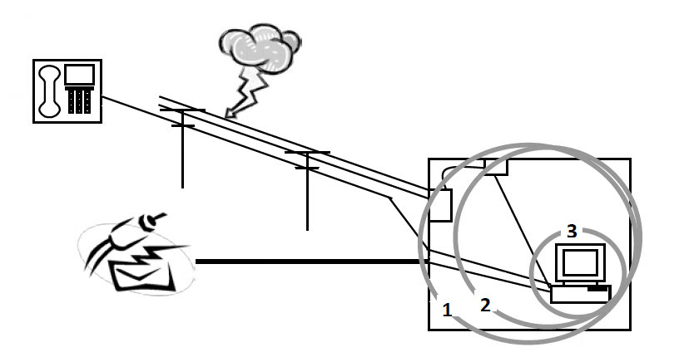
The zones of protection approach is designed to control surges at their initial point of entry or reduce them to a level that can be controlled at the next stage

ESOs are becoming more reliant on electronic equipment to provide vital services. The use of SPDs may help an ESO protect this equipment and to help assure uninterrupted service, it is important to protect that equipment from electrical surges. It is strongly recommended that a professional engineer experienced with surge suppression technology be retained to design the protection system for the facility to verify all SPDs are properly sized and coordinated.2

This is a sample guideline furnished to you by VFIS. Your organization should review this guideline and make the necessary modifications to meet your organization’s needs. The intent of this guideline is to assist you in reducing exposure to the risk of injury, harm or damage to personnel, property and the general public. For additional information on this topic, contact your VFIS Risk Control representative.

References:
VFIS Risk Communique – “Surge Protection Devices – Protecting Sensitive Electrical Equipment”

IEEE Standard 1100 - IEEE Recommended Practice for Powering and Grounding Sensitive Electronic Equipment, 2005

Hartford Steam Boiler: Guidelines for Providing Surge Protection at Commercial, Institutional and Industrial Facilities, 2008

