REPLACE WITH YOUR MASTHEAD
 | SOG Title:
 | SOG Number:
 | Original Date: | Revision Date:

ABC Fire Department General Operating Guideline

Decontamination

This is a sample of a standard operating guideline (SOG) on this topic. You should review the content, modify as appropriate for your organization, have it reviewed by your leadership team and if appropriate your legal counsel. Once adopted, make sure the SOG is communicated to members, implemented and performance monitored for effective implementation.

Purpose:
Hazardous Material contamination of emergency personnel and civilians is significantly increased if decontamination is not performed properly and completely. The ____________ Fire Department shall operate as the principal organization to decontaminate all personnel and civilians accidentally exposed to hazardous materials. The ____________ Fire Department will supply support services in reference to decontamination to mutual aid agencies that provide personnel to mitigate Hazardous Material incidents.

Decontamination of the involved Hazardous Material(s) can only be accomplished if adequate equipment and training is available.

Procedure:
Operations
- The safety officer is responsible to ensure that all individuals that may have been exposed to Hazardous Materials are properly decontaminated prior to leaving the scene
- All transporting ambulances shall stage in the Cold Zone and only receive patients that have been decontaminated
- As required, ____________ Fire Department personnel shall assist all EMS units in the proper protection of these vehicle to transport patients including:
  - Setting aside necessary equipment from interior compartments
  - Removal of non-essential equipment from the interior of the ambulances
  - Placing protective barriers (sheet plastic) over the walls of the interior and the taping of compartment doors
  - Provide equipment to encapsulate patients (splash protection suits)
  - Removal of mattress from cot
  - Provide required protective clothing to EMS personnel
- Decontamination shall be performed at incidents where a known or suspected exposure has occurred.
- Decontamination shall be performed at incidents where the safety officer or incident commander determines that it is required.
- The ____________ Fire Department’s Decontamination Process will be based on The Environmental Protection Agency’s 9 Step Process for decontamination.
- The E.P.A. 9 Step Process:
  - Establish an Entry Point.
    - This area is where all personnel shall exit the Hot Zone
    - All tools and equipment shall be left in this area
    - The Entry Point shall be marked with YELLOW barrier tape
  - Establish Primary Decontamination
    - Remove the chemical as much as possible by showering the person with water in this area
    - Emergency personnel shall continue to wear the required protective equipment (including S.C.B.A) in this area
    - Victims shall be decontaminated with clothes on
  - Remove S.C.B.A.
    - S.C.B.A shall be removed prior to proceeding to the next step.
  - Removal and Isolation of Protective Clothing
    - Outer protective clothing shall be removed and placed into plastic bags (especially important if clothing is porous firefighting equipment)
  - Removal of Personal Clothing
    - All personal clothing, including jewelry shall be removed and placed into plastic bags separate from the protective clothing
    - It is of great importance that privacy be maintained as much as possible during this process
  - Decontamination of the Body
    - The body shall be washed completely with soap.
    - Special attention to hair and groin area is required.
  - Dry Off and Don Clean Clothing.
    - Towels used to thy off and placed into plastic bags.
    - Preferably personnel and victims that are able to utilize them should use disposable suits (Tyvek)
    - Injured victims should be wrapped in sheets
  - Medical Evaluation
    - Personnel shall be evaluated and triaged by medical personnel
    - After evaluation, patients should be placed in ambulances in the Cold Zone
  - Transportation
    - Injured victims shall be transported first
    - If a risk of secondary contamination is possible, all personnel who require decontamination shall be transported to the hospital for evaluation
- All water runoff from decontamination will be contained, removed and disposed of by an approved agency
- All contaminated clothing and equipment will be bagged and removed by a cleanup contractor
- All ambulances that transported contaminated patients shall be placed out of service until a proper metering device is available to determine if the ambulance requires decontamination
- Personnel on the Decon line shall wear a Level B protection for the purpose of safety and will be considered to be in the defensive mode
- No personnel wearing Level B clothing shall be allowed in the Hot Zone
- The following diagram is a typical Decontamination Line operation

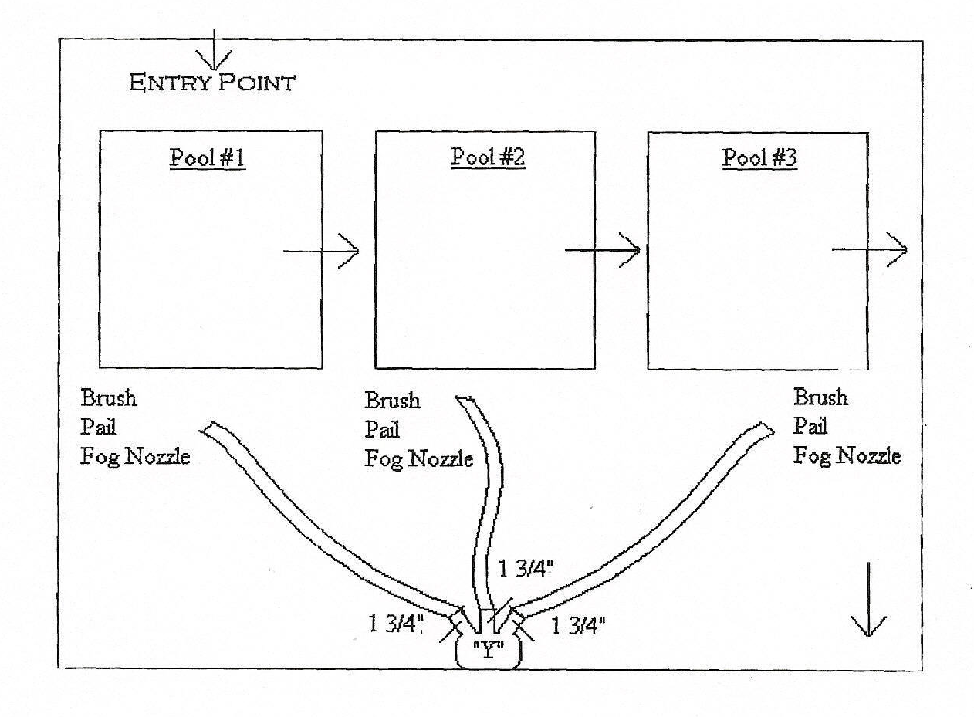

This is a sample guideline furnished to you by VFIS. Your organization should review this guideline and make the necessary modifications to meet your organization’s needs. The intent of this guideline is to assist you in reducing exposure to the risk of injury, harm or damage to personnel, property and the general public. For additional information on this topic, contact your VFIS Risk Control representative.

References:
West Redding (CT) VFD – GOG 8-OHM-810 Developed/Revised/Reviewed by VFIS ETC

