REPLACE WITH YOUR MASTHEAD
 | SOG Title:
 | SOG Number:
 | Original Date: | Revision Date:

ABC Fire Department General Operating Guideline

Extrication Process

This is a sample of a standard operating guideline (SOG) on this topic. You should review the content, modify as appropriate for your organization, have it reviewed by your leadership team and if appropriate your legal counsel. Once adopted, make sure the SOG is communicated to members, implemented and performance monitored for effective implementation.

Purpose:
The purpose of the following standard is to provide information regarding the several varying extrication processes that are available to provide rapid removal for victims from motor vehicles. Training of these processes should occur at least annually for safe and efficient operations. Since the construction and materials of motor vehicles differ depending on the year, make and type, variations of the following processes may be required.

Procedure:
Vehicle Terminology
The following terms are utilized in the extrication processes to identify, areas of the:
- “A” pillar (post)
- “B” pillar (post)
- “C” pillar (post)
- “D” pillar (post)
- Hinge side
- Latch side
- Nader bolt (bolt that latch grabs to hold door closed)
- Roof rail
- Rear quarter panel
- Rocker panel or channel
- Kick panel
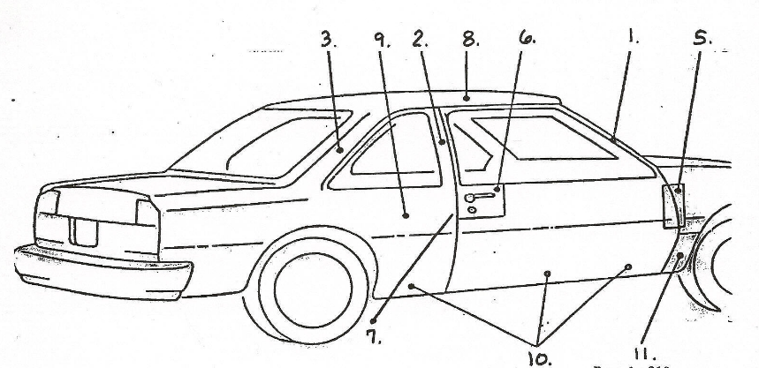
Extrication Processes
- Creating an opening in the door with the Halligan bar and flat head axe.
  - Performed to allow for a wider area for the tip of the Spreaders to be placed to open a door.
  - Completed by placing the flat blade of the Halligan bar against the door on the latch side in the area of the Nader bolt and hitting the bar with mild exertion with the flat head of the axe. Once the bar is seated, the bar is rotated up and down to make a ¾” to 1 ½” wide opening in the door.

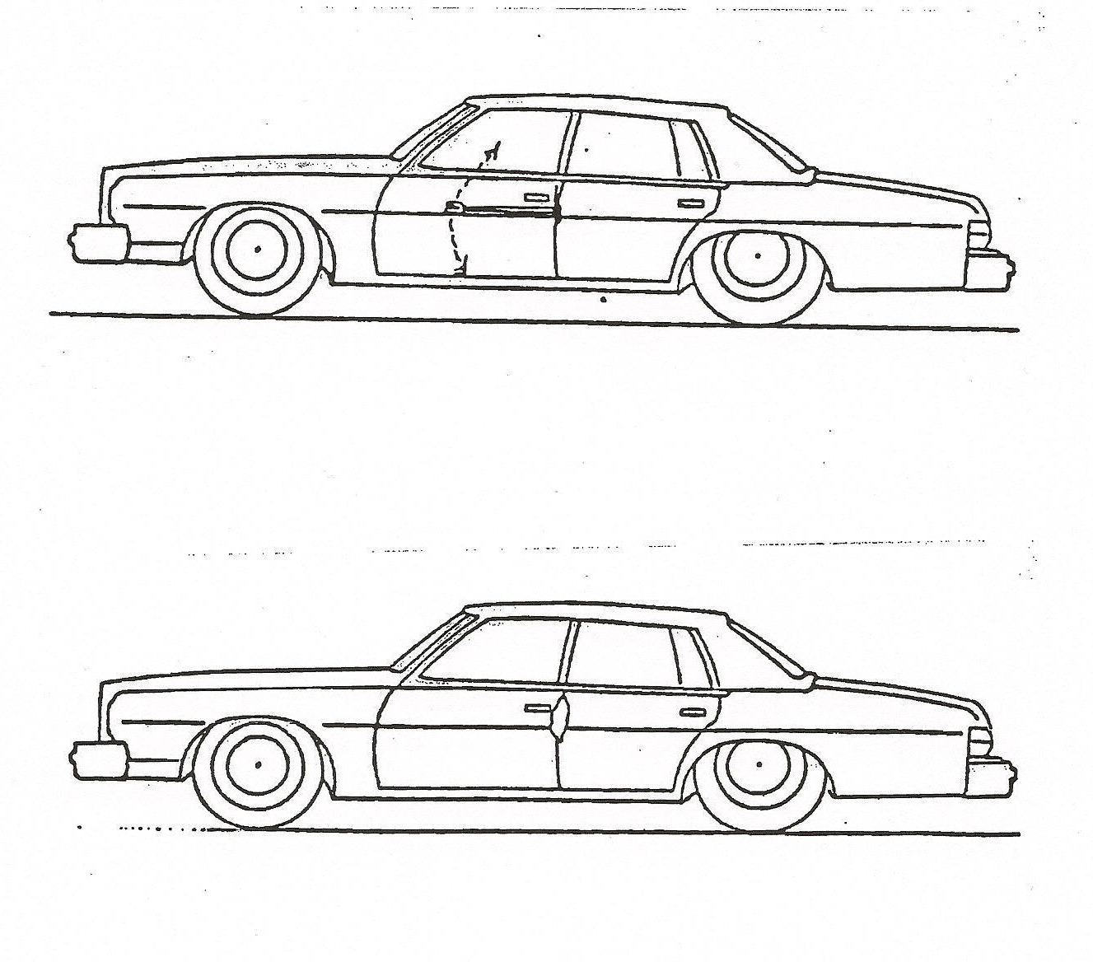

- Creating and opening in the door utilizing the spreaders (known as the “Lift Method”.).
  - Insert the spreaders into the window opening while maintaining a downward angle.
  - As the tool is opened to its widest point and performed properly, the door will crush and begin to roll down and out.
  - Be aware that when creating the opening with the spreaders, the door may open in one operation.
  - This operation should cause the door to pull away from the “B” pillar (post) to allow for the tips of the spreaders to be placed into the latch side to open the door.

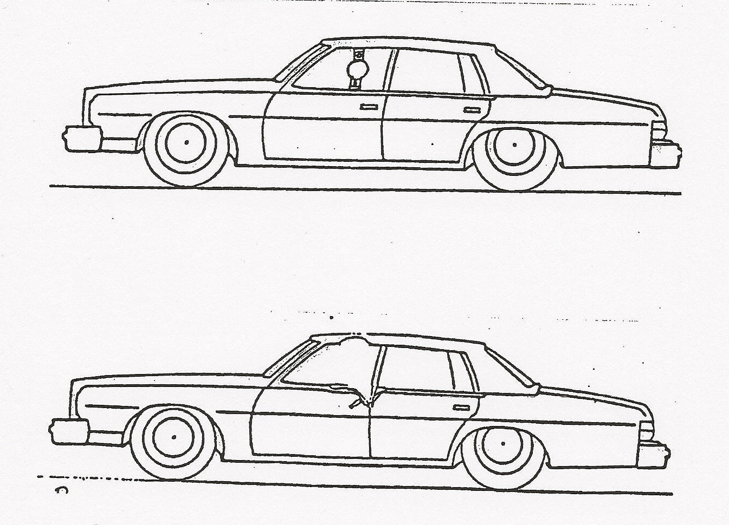

- Creating an opening in the door by squeezing with the spreaders.
  - Open spreaders wide enough to position the tool in the middle of the window opening and that the tips are approximately eight (8) inches down from bottom of window opening.
  - Close the spreaders to “crimp” the door and the door should separate from the “B” pillar (post) to allow room for the Jaws to be placed into the latch side to open the door.

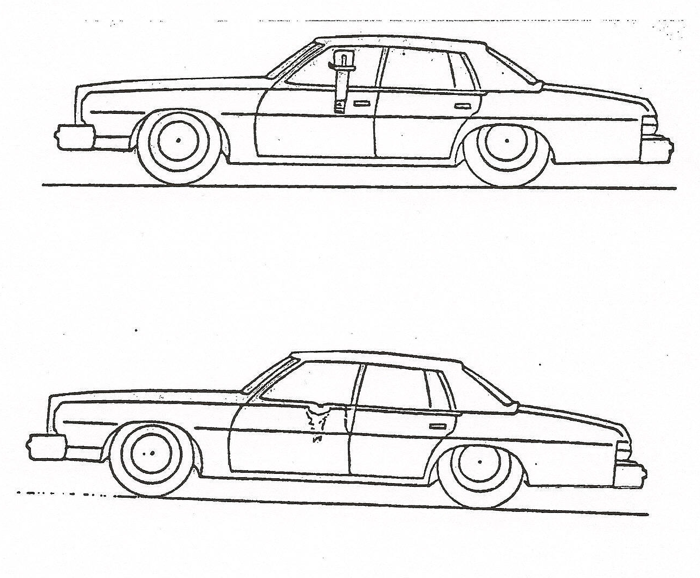

- Third Door Operation
  - Used to make a “rear door” on two door vehicles.
  - Useful if unable to open doors by placing Spreaders near “B” pillar (post) on latch side of front door on hinge side of read door
  - Useful if large opening is required for removal of victim, multiple victims, or for medical care especially if vehicle only has two doors.
  - Set up method:
    - Remove front door completely
    - Cut or eliminate “B” pillar (post)
    - Cut as deep as possible into body of vehicle near “C” pillar (post)
    - Cut .as deep as possible into body using “pie cut” if required.
    - Place spreaders or long ram into window opening and open as far as possible, making sure that direction of spread is down and out.
    - To enlarge the opening, place large ram from the curve of the “A” pillar (post) to a point on the section of the vehicle that was pushed down and out in the set up operation.
    - If a large ram is not available, place a small ram at a point where the top of the “H” pillar (post) was removed and on the section that was pushed down and out.
    - Extend the ram to further push the vehicle section down and out as far as possible

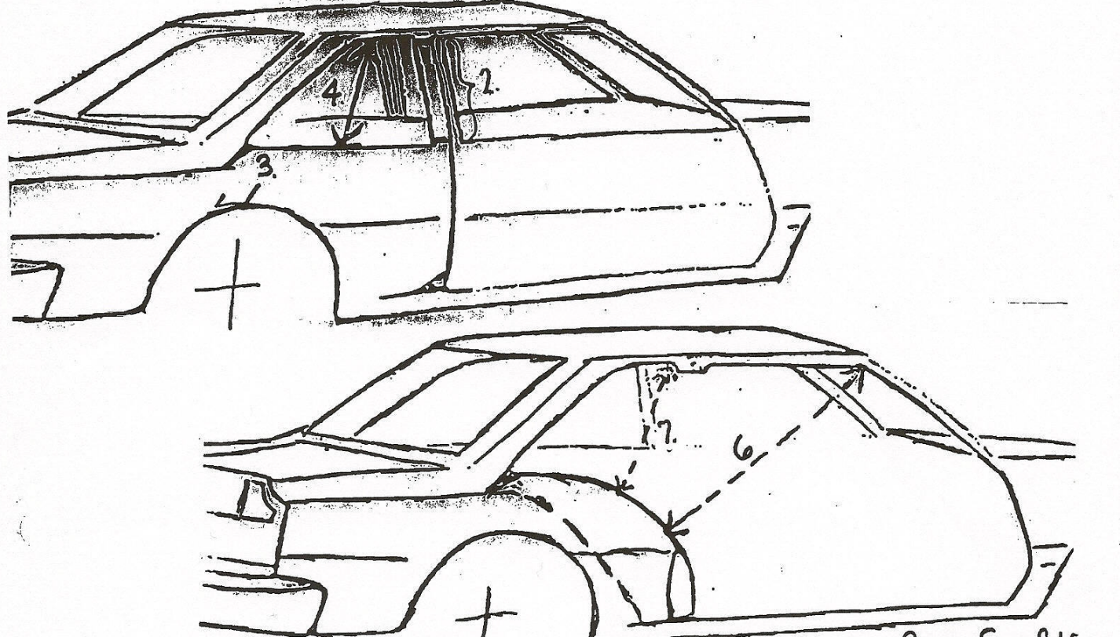
- Seat Displacement
  - Used to move the seat away from the dashboard and can be performed with the door removed or attached as needed
  - The spreaders are placed between the hinge side of the door opening and the seat frame
  - The spreaders are opened until the seat is moved back as needed or until seat frame separated from floor
  - This maneuver should be performed slowly to prevent excessive jarring and to protect any victims
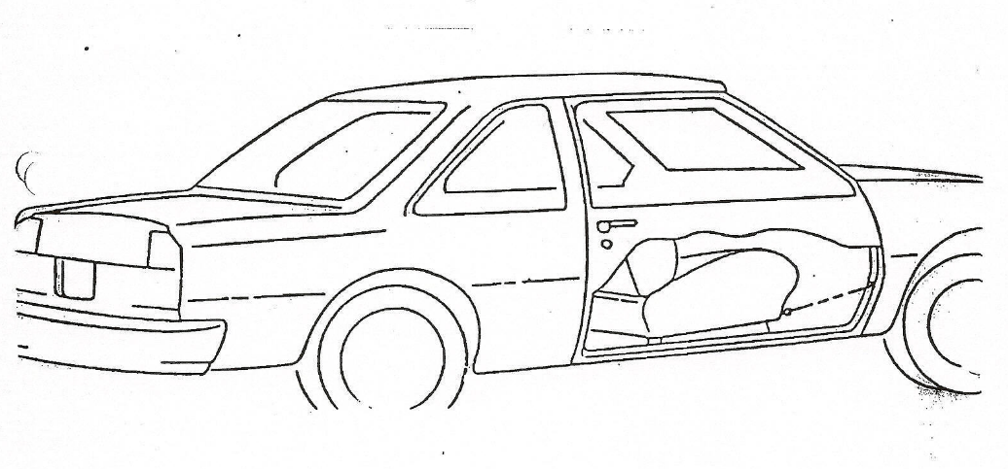
- Steering Column Pull (over the hood method)
  - Use to pull steering column and dashboard up and away from victim
  - Maneuver can be performed with roof still attached. Windshield needs to be removed or cut away.
  - Maneuver requires two (2) heavy chains with hooks at least on one end of each, spreaders with chain attachment tips, “O” cutters and thick blocks or cribbing.
  - Steering column pull method set up:
    - Remove roof or cut away windshield.
    - Make “pie cut” above top hinge and below bottom hinge on drivers side opening.
    - Place spreaders on hood, positioning tool on and angle and open spreaders completely.
    - Place thick cribbing on hood at base of windshield (amount of cribbing required depends on the distance needed for the column to be moved).
    - Wrap one (1) heavy chain around bottom of steering column as low as possible and connect other end to Spreaders making the chain as taut as possible.
    - Place additional thick cribbing over bumper in the front of the passenger side of the vehicle.
    - Wrap second heavy chain over suspension or frame on passenger side and run chain over cribbing and connect end to the spreaders making the chain as taut as possible (a thin piece of cribbing, e.g., 2x4, may be required under chain at edge of hood).
    - Slowly close spreaders until the steering column is moved an adequate distance for victim removal.
    - Although uncommon, if more distance is required and the spreaders have closed completely, secure the steering column from retracting and open spreaders fully to remove and reposition the chains to repeat procedure.
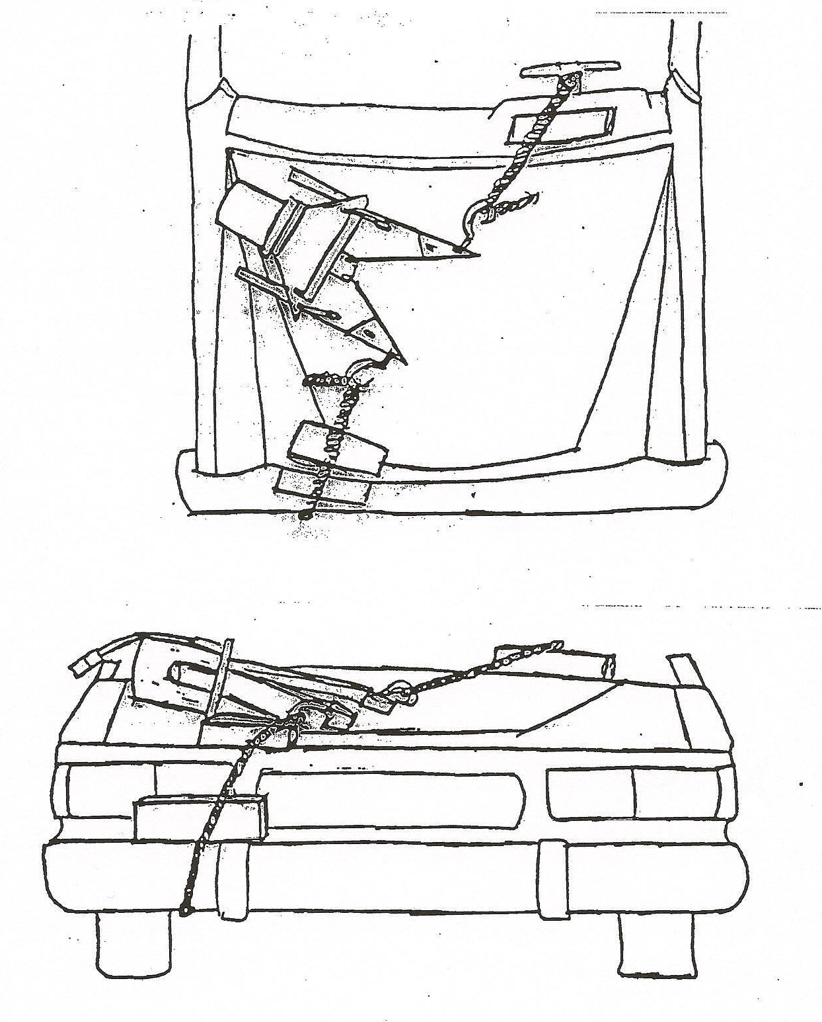

- Steering column pull (alternative method).
  - Steering columns can be moved short distances with alternative methods if required.
  - Fill the void between the rocker panel and the ground with cribbing.
  - Make a “pie cut” between the bottom hinge and crimp the rocker panel with the spreaders and leave in place.
  - Position one end of the ram next to the tip of the Spreaders and the other end under the bottom of the steering column.
  - Extend the ram until the steering column is displaced enough to allow removal of the victim.
  - It is important to leave the ram in place to prevent the steering column from dropping back down.
  - The drawback of this alternative method is that further operations have to take place around the tools and this should be considered prior to implementing this procedure.
  - The steering column can be displaced using a ram placed between the column and the bottom of the “B” pillar (post) and extending the Ram as far as needed. At least a 60” ram is required for this procedure.

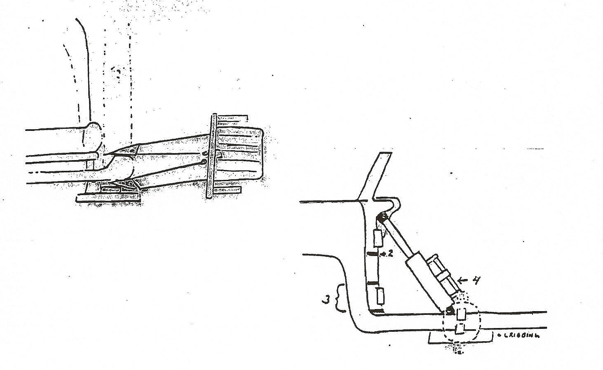

- Roof Removal
  - Roof removal is a common extrication procedure and allows substantial access to victims and for victim removal.
  - Roof removal is performed prior and in conjunction with other extrication procedures.
  - Roof removal can be completed with the windshield attached to the roof or can be removed otherwise.
  - The windshield needs to be cut completely across the bottom and can be performed with a reciprocating saw or a commercial glass saw.
  - Personnel are positioned at least at each corner and if available, on each side in the center to support the roof for further operations.
  - If personnel are not available, cuts must be coordinated to prevent the roof from dropping into the passenger compartment.
  - Utilizing the “O” cutters, make cuts at the bottom of the “A”, “B” and “C” pillars (posts) on both sides of the vehicle (the “A” pillar (post) cuts must be flush with the bottom of the windshield cut).
  - In coordination, the roof is then lifted up and removed from the vehicle.
  - Caution must be exercised around the vehicle posts where the cuts were made as sharp edges remain.

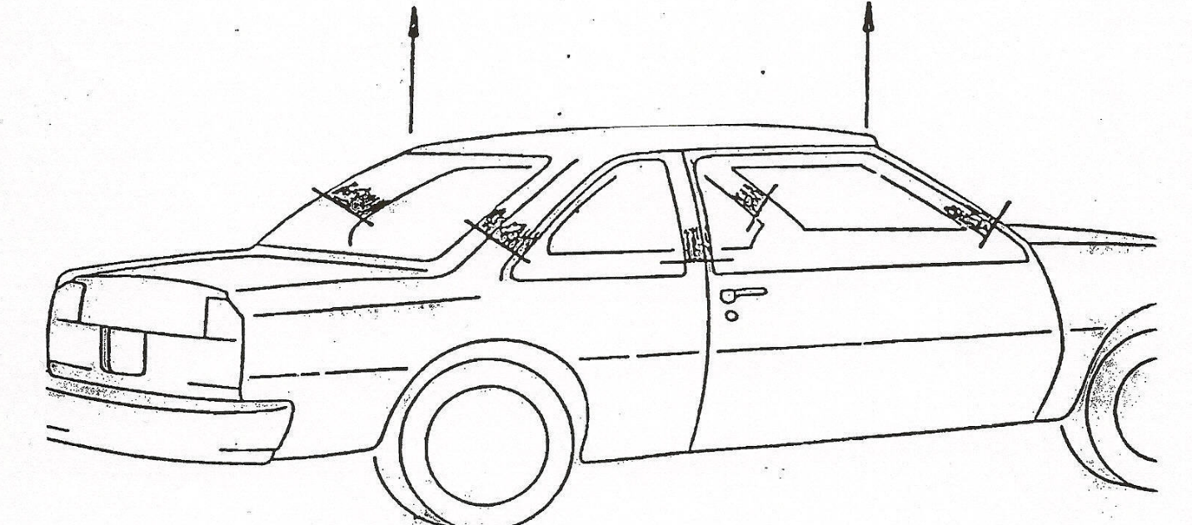

This is a sample guideline furnished to you by VFIS. Your organization should review this guideline and make the necessary modifications to meet your organization’s needs. The intent of this guideline is to assist you in reducing exposure to the risk of injury, harm or damage to personnel, property and the general public. For additional information on this topic, contact your VFIS Risk Control representative.

References:
West Redding (CT) VFD – GOG 7-OR-702 Developed/Revised/Reviewed by VFIS ETC

