REPLACE WITH YOUR MASTHEAD
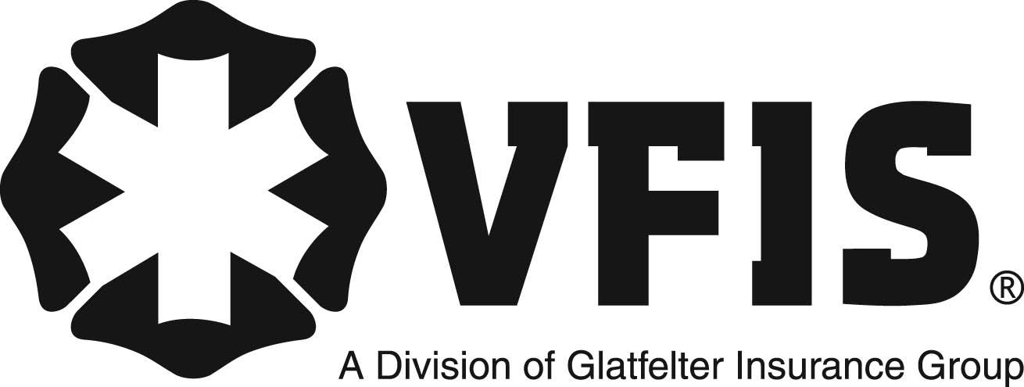 | SOG Title:
 | SOG Number:
 | Original Date: | Revision Date:

ABC Fire Department General Operating Guideline

Personal Appearance

This is a sample of a standard operating guideline (SOG) on this topic. You should review the content, modify as appropriate for your organization, have it reviewed by your leadership team and if appropriate your legal counsel. Once adopted, make sure the SOG is communicated to members, implemented and performance monitored for effective implementation.

Policy:
To establish a positive image to the public.

Purpose:
The personal appearance of fire department personnel is viewed by the public as an indicator of both individual and department professional attitude and competence. Given the nature of work conducted by members, the safety of all personnel necessitates that some specific areas of personal appearance be directly addressed.

Scope:
This applies to all organization personnel.

Procedure:
Supervisors will advise those within their command of the grooming standards and assure
conformity. It shall be the duty of the responsible supervisor to assure that personal grooming shall not interfere with the wearing of safety equipment, facemask, or other personal protective equipment. The supervisor will take immediate corrective actions to assure safety.

Any member with a medical condition that precludes conforming to these grooming standards
shall notify their Chain-of-Command and to request an exception approval from the Fire Chief. This type of exception may require reassignment or the employee might not be able to work.

Hair Standards:
Occupational Safety and Health Administration (OSHA) 1910.134(g)(1), states that an effective tightfitting facepiece requires the face to be in direct contact with the respirator seal. Any facial hair that is between the facepiece seal and face can cause the seal to not work effectively. This policy shall support OSHA 1910.134 (g)(1) by not having any facial hair between the face and respirator seal thus providing the highest level of safety for its members in Immediately Dangerous to Life or Health (IDLH) environments. Hair, sideburns, mustaches, and articles of clothing must never interfere with the use of personal protective equipment (PPE), including helmets and SCBA mask. As long as the hair style does not lessen the protection of required safety equipment or expose personnel to added personal injury the acceptability of the style will be evaluated by the following criteria:

Males:
• Hair will be clean, neat, well trimmed, and appropriately groomed at all times.
• Hair will not present a ragged or unkempt appearance.
• In no case will the bulk of hair interfere with the wearing of a SCBA, helmet, or protective
hood.
• Hair will not cover more than three-fourths (3/4) of the ear.
• Hair will not extend below the bottom edge of the uniform collar, at the back of the neck when
standing.
• Hair will not be dyed an unnatural color.
• Hair will not be worn in an extreme or fad style such as a Mohawk, ducktail, braids, or in a way
that exceeds length standards.
• With the exception of appropriate mustaches and sideburns, no facial hair is allowed
• Mustaches will be kept in a groomed and trimmed manner at all times
• No mustache shall be waxed or twisted at the ends, or pulled to a point in any manner
• Mustache may not exceed more than ½ inch beyond or ½ inch below the corner of the mouth
• Under no circumstances will the mustache be permitted to cover the mouth, extend to a point
that interferes with the seal of the SCBA face piece or be flared on the bottom edges.
• Sideburns will be kept in a groomed and trimmed manner at all times.
• Sideburns will not extend below the bottom of the earlobe, be flared, or bushy, and will end in
a clean-shaven horizontal line
• No Beards, No Goatees, No soul-patches while in uniform or on duty.

Females:
Female personnel will conform to the same grooming requirements as male personnel except for the following:
• Hair shall not exceed in length on all sides below an imaginary line drawn parallel across the
bottom of the shoulder blades.
• Hair may be worn down during non emergency activities.
• During emergency operations, training activities, apparatus and equipment maintenance hair
shall be pinned up or covered and shall not interfere with the wearing of headgear, SCBA or
become an entanglement hazard.
• Hair must not cause an exposure / contamination issue during emergency medical operations.
• Items used by female personnel to hold the hair in place will be concealed as much as possible,
and will be of a color and style that blends with the hair.
• Plastic items such as combs and ribbons shall not be worn in the hair.

Fingernails:
• Fingernails will be neat and clean, and not extend beyond the tips of the fingers.
• If nail polish is worn, it will be clear.

Cosmetics:
• Personnel may be permitted to wear cosmetics of conservative color and amount.

Jewelry Standards:
• Earrings and other body piercings will not be worn while in uniform or on duty.
• Neck chains may be worn, but must remain concealed from view beneath the uniform shirt.
• Watches, rings, and bracelets may be worn if they are snug fitting and do not compromise the
safety of the individual.
• Consideration shall be given to the wearing of gloves to protect the hands and fingers while
performing work with power tools or other devices that jewelry may “hang” on.

Piercings:
Other than ear piercing holes for small post earrings, no visible body piercing (or piercing hole), to include nose, eyebrows, and tongues shall be visible while in uniform or on duty. No “gauges” or earrings that could interfere with performing assigned duties is permitted while in uniform or on duty. Piercing holes larger than those to accommodate a small post earring must be closed or covered while in uniform or on duty.

Tattoos and Brandings:
Employees should not reveal or display inappropriate tattoos or brandings while in uniform or on duty.

Supervisory Actions
If a question arises as to the appropriateness of a member’s appearance, the appropriate
Supervisor will be notified though the Chain-of-Command. The supervisor will provide a recommendation to the Fire Chief for final determination.

Any person found violating this policy will be asked to immediately take the necessary action to correct the condition or leave work and return at their own expense once the condition is resolved. Progressive discipline shall be used for repeated violations of the procedure.

Personnel Accommodation
Should a member believe an exception or accommodation is in order, a request should be made in writing through the chain of command, consistent with the Personnel Manual.

This is a sample guideline furnished to you by VFIS. Your organization should review this guideline and make the necessary modifications to meet your organization’s needs. The intent of this guideline is to assist you in reducing exposure to the risk of injury, harm or damage to personnel, property and the general public. For additional information on this topic, contact your VFIS Risk Control representative.

Reference:
College Station TX Fire Department Standard Operating Guidelines.

