REPLACE WITH YOUR MASTHEAD
 | SOG Title:
 | SOG Number:
 | Original Date: | Revision Date:

ABC Fire Department General Operating Guideline

Self Inspection Form for Buildings & Grounds

This is a sample of a standard operating guideline (SOG) on this topic. You should review the content, modify as appropriate for your organization, have it reviewed by your leadership team and if appropriate your legal counsel. Once adopted, make sure the SOG is communicated to members, implemented and performance monitored for effective implementation.

Purpose:
Periodic inspection of your organization’s buildings and grounds can alert you and your maintenance staff to hazards which may cause damage and accidents to your buildings and those who use it. This form is provided for periodic self-inspection and is recommended for use on a quarterly basis to assist you in discovering hazards before an accident can occur. Correct all negative conditions immediately.

This self-inspection form does not intend to point out all hazards and exposures which may be found at your building. It is intended to be used as a guide to highlight major areas of exposure which are common to most emergency service organization buildings. The use of this form does not warrant that all hazards will be found and corrected.

Procedure:
Please check Yes, No or NA (not applicable) answers to all questions below. All “No” answers indicate an area of unsatisfactory conditions and comment regarding same should be made in the space provided on the back of this form. Use a separate sheet for each building.

Form Statistics:

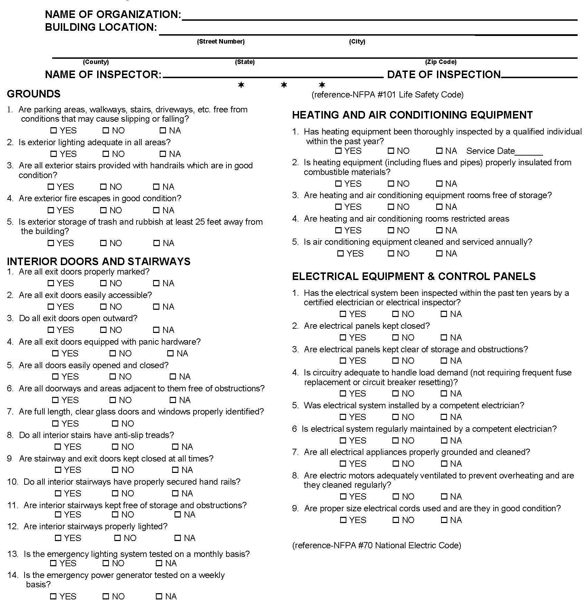
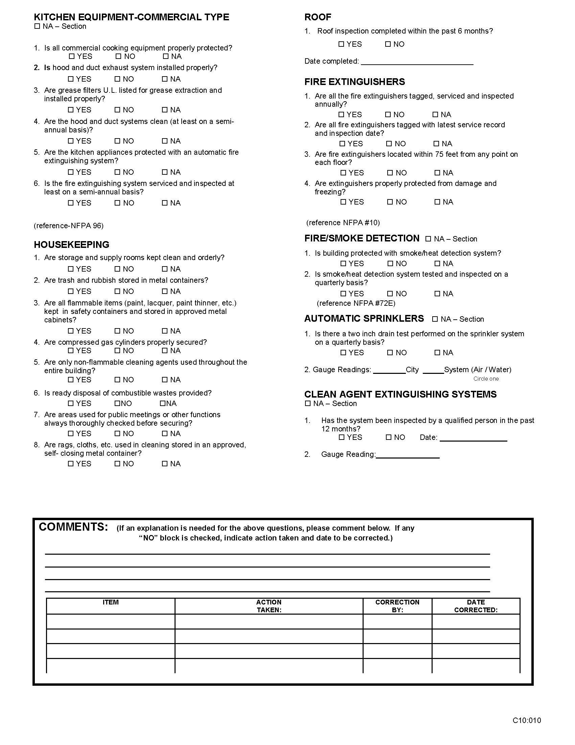

This is a sample guideline furnished to you by VFIS. Your organization should review this guideline and make the necessary modifications to meet your organization’s needs. The intent of this guideline is to assist you in reducing exposure to the risk of injury, harm or damage to personnel, property and the general public. For additional information on this topic, contact your VFIS Risk Control representative.

References:
VFIS Self Inspection Form for Buildings & Grounds

