REPLACE WITH YOUR MASTHEAD
 | SOG Title:
 | SOG Number:
 | Original Date: | Revision Date:

ABC Fire Department General Operating Guideline

Backing Vehicles

This is a sample of a standard operating guideline (SOG) on this topic. You should review the content, modify as appropriate for your organization, have it reviewed by your leadership team and if appropriate your legal counsel. Once adopted, make sure the SOG is communicated to members, implemented and performance monitored for effective implementation.

Purpose:
To ensure vehicle is safely moving when operating in reverse (backing up) mode.

Scope:
All personnel.

Procedure:
It is the primary responsibility of the driver and officer to ensure the vehicle is safely moving in a reverse position, to prevent death, injury, and property damage. Practice the following:
- When backing the apparatus, there must be a spotter, visible to the driver
- When backing, the vehicle will be under the direction of the person at the back of the vehicle, who is in the sight of the driver
- Operator will respond to all directions made by the person directing the backing of the vehicle. Do not operate the vehicle unless the "spotter" is in sight
- Take a three-dimensional look while backing to assure overhead obstructions are identified
- Back up SLOWLY
- In cases where there is no spotter available, the operator MUST perform a “360” walk around to assure there are no obstacles or challenges in backing up

Signals
- Straight Back: Palms facing the directions of desired travel, bend both arms repeatedly toward the head and above the chest, and then extend.
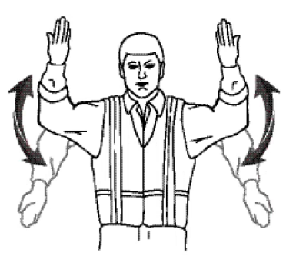

- Left Turn: Facing the vehicle, raise right arm to side, bending at the elbow. Face palm outward and move hand to left.
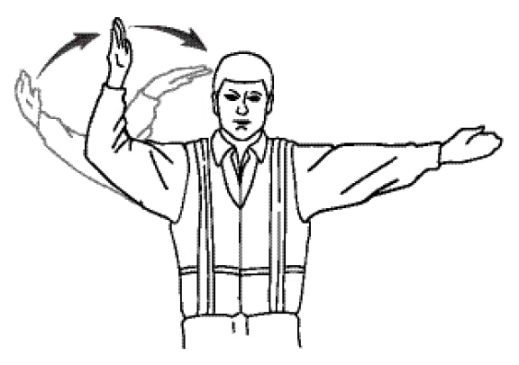

- Right Turn: Facing the vehicle, raise left arm to side, bending at the elbow. Face palm outward and move hand to right.
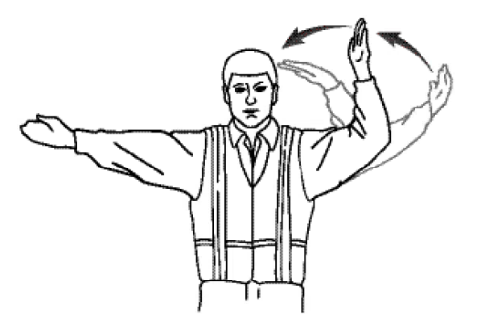

- Stop: Extend arms above head, cross hands at the wrists.
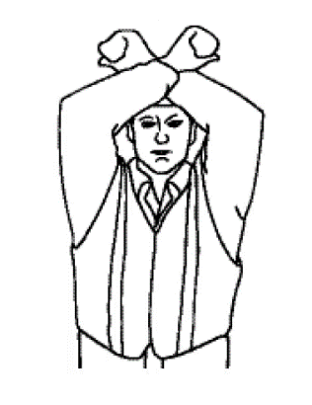

Night Backing
Signals will be the same. The spotter will ensure that the spotlights on rear of apparatus are turned on before allowing apparatus to be backed. A flashlight may be carried, but at no time will it be directed toward the mirror.

This is a sample guideline furnished to you by VFIS. Your organization should review this guideline and make the necessary modifications to meet your organization’s needs. The intent of this guideline is to assist you in reducing exposure to the risk of injury, harm or damage to personnel, property and the general public. For additional information on this topic, contact your VFIS Risk Control representative.

References:
NVFC "Emergency Vehicle Safe Operations for Volunteer and Small Combination Emergency Service Organizations"

VFIS “Emergency Vehicle Driver Training”

