REPLACE WITH YOUR MASTHEAD
 | SOG Title:
 | SOG Number:
 | Original Date: | Revision Date:

ABC Fire Department General Operating Guideline

Non-Members Riding in ESO Vehicles

This is a sample of a standard operating guideline (SOG) on this topic. You should review the content, modify as appropriate for your organization, have it reviewed by your leadership team and if appropriate your legal counsel. Once adopted, make sure the SOG is communicated to members, implemented and performance monitored for effective implementation.

Purpose:
Parades, Fire Prevention Week, citizen ride-along programs and similar public relations events provide great opportunities for emergency service organizations (ESOs) to promote their organization's activities. These events can assist in fostering positive relationships with local citizens. During these events, there may be instances where non-members are allowed to ride in department vehicles. While these activities are an important part of public service activities for the ESO, there are inherent risks associated with ride along programs.

Procedure:
To help reduce the risk of accident and injury to a non-member riding in ESO vehicles, consider developing standard operating guidelines.

For community type events (e.g., parades) consider the following:
- Assign dedicated vehicles to be used for these events and designate the maximum number of non­members allowed to ride the apparatus at any given time.
- Do not exceed the designed occupancy of the vehicle and ensure that all passengers are properly seated and utilizing a seat belt.
- Do not allow individuals to ride on the tailboard, hose beds or any other area outside of the cab.
- Limit exposures to the planned event only. Do not allow non-members to ride along in emergency situations unless prior authorization is provided (see below).
- Formalize procedures for unloading and loading non-members into and out of the vehicle.
- Perform a walk around to ensure the vehicle is safe to move after the boarding and departing process.

For ride-alongs, where an emergency response may be undertaken:
- Establish a minimum age requirement for non-members.
- Develop and implement procedures to protect the privacy of patients and members of the public.
- Outline rules to be followed by the non-member.
- Adopt a release/waiver for non-members who will ride and require the waiver be signed prior to allowing the individual to ride. All minors must have a waiver signed by a legal guardian.
A sample release/waiver is attached. Have this reviewed by legal counsel to assure that it provides adequate protection in the operational jurisdiction.

By understanding the importance of formalizing department ride along policies and adopting these or similar best practices into your organization's procedures, ESOs can help reduce the risk of potential injury to non-members riding in department vehicles.

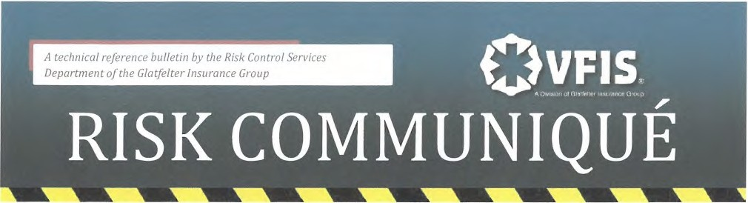
(Sample Riding Policy)

RELEASE AND IDEMNIFICATION AGREEMENT
I, _______________________________________ fully understand that riding in an ambulance/fire apparatus is a dangerous activity which can result in personal injury and property damage. I realize that the risks inherent in riding in an ambulance/fire apparatus and observing emergency procedures include, but are not limited to, injury from collision, the administration of medical treatment to ambulance patients, firefighting activities and the proximity to medical ailments. I expressly assume all risks, including all personal injury and property damage, which may occur.

In consideration for permitting me to ride in the ambulance/apparatus, hereby release ______________ its directors, officers, shareholders, employees, agents, successors and assigns from any and all rights, claims, demands, action and causes of action of any nature whatsoever, whether arising in law or in equity, by reason of any matter, cause,happening, thing,act or omission and, in particular, but without limiting in any way the generality of the foregoing, I do hereby release its directors, officers, shareholders, employees, agents, successors and assigns from any liability for personal injuries or property damage suffered or sustained by me, whether caused by the inherent risks involved in riding in an ambulance/apparatus or caused either wholly or in part by the intentional or negligent act of its volunteers, employees, agents or representatives.

Furthermore, in consideration of permitting me to ride in the ambulance/fire apparatus, I agree to indemnify, defend and hold harmless ______________________ for all liability caused either wholly or in part by me which results in personal injury or property damage including all losses, costs and attorney's fees, claims and judgement. In addition, I agree to indemnify, defend or hold harmless _______________ its directors, officers, shareholders, employees, volunteers, agents, successors and assigns for all liability for any acts of omissions which result in personal injury or property damage including all losses, costs, attorney's fees, claims and judgments whether committed either wholly or in part by the intentional or negligent acts or omissions of agents of _________________ or any other person. Ialso agree to pay all costs and attorney's fees incurred in enforcing the terms of the release and indemnity agreement.

This release and indemnity agreement shallbe binding upon me, my assigns, heirs and successors.

Signature

Name (Please Print)

Street Address

City, State, Zip Cose

Date
This is asample guideline furnished to you by VFIS. Your organization should review this guideline and make the necessary modifications to meet your organization's needs. The intent of this guideline is to assist you in reducing exposure to the risk of injury, harm, or damage to personnel, property, and the general public. For additional information on this topic, contact your VFIS Risk Control Representative at {800} 233-1957.
© 2011 VFIS. All Rights Reserved

This is a sample guideline furnished to you by VFIS. Your organization should review this guideline and make the necessary modifications to meet your organization’s needs. The intent of this guideline is to assist you in reducing exposure to the risk of injury, harm or damage to personnel, property and the general public. For additional information on this topic, contact your VFIS Risk Control representative.

References:
VFIS Risk Communiques “Non Members Riding in ESO Vehicles”

