REPLACE WITH YOUR MASTHEAD
 | SOG Title:
 | SOG Number:
 | Original Date: | Revision Date:

ABC Fire Department General Operating Guideline

Vehicle Safe Operations

This is a sample of a standard operating guideline (SOG) on this topic. You should review the content, modify as appropriate for your organization, have it reviewed by your leadership team and if appropriate your legal counsel. Once adopted, make sure the SOG is communicated to members, implemented and performance monitored for effective implementation.

Purpose:
To provide a guideline to emergency vehicle driver/operators, officers and all personnel involved in movement and direction of emergency vehicles.

Procedure:
- ____________ Fire Department vehicles shall be operated in a fashion that contributes to the safety of all persons and property.
- All vehicles, including personal vehicles will be operated in compliance with ____________ General Statutes.
- Operators of ____________ Fire Department vehicles shall be directly responsible for the safe and sensible operation of the vehicles wider all circumstances. When i driver is under the supervision of an officer, that officer shall also assume responsibility for the actions of the driver.
- Drivers shall not move fire department vehicles until all personnel are seated and secured with seat belts or in approved riding positions. EMS personnel actively performing medical care in the ambulance while the vehicle is in motion shall be secured by a seat belt to the extent to allow effective application of such emergency medical care.
- Under no circumstances shall any personnel ride on a moving vehicle in any position other than approved riding positions.
- Code 1 responses are defined as the use of emergency lights and audible warning devices with the optional use of air horns while en-route to an emergency incident.
- Code 2 responses are defined as responding with the flow of traffic without the use of emergency lights and audible warning devices.

Emergency Response
- Departing the Station
  - Driver shall look down both sides of the vehicle to assure that no compartment doors are open and the area is free of obstructions prior to mounting the apparatus. No compartment door shall be left open and no unsecured objects shall be left on the apparatus while unattended under any circumstances.
  - The driver shall safely and efficiently mount the apparatus
  - All personnel on board shall be secured with seat belts
  - Hearing protections shall be worn if required
  - The apparatus bay door shall be assured to be completely open
  - The driver shall be sure of destination and know a convenient route prior to departing station.
  - Code 1 response is approved only in conjunction with emergency incidents. The use of a Code 1 response does not automatically give the right of way to emergency vehicles but is to request the right of way from other vehicle operators based on theft awareness of the emergency vehicle presence. Emergency vehicle operators must make theft presence and intentions known to other vehicles, and must drive defensively and be aware of the unexpected actions of others.
  - When approaching and crossing an intersection with the right of way, drivers shall not exceed the posted speed limit. When it is necessary louse the center of the opposing lane to approach an intersection controlled by traffic lights or stop signs, the vehicle shall come to a complete stop prior to proceeding through the intersection, including situations where your direction of travel has the green traffic light.
  - When approaching an intersection where your direction of travel has a red traffic light or stop sign, the vehicle shall come to a complete stop and proceed only when the driver is assured that oncoming traffic in all lanes has yielded the right of way.
  - During emergency response, emergency vehicles shall avoid passing other emergency vehicles. If passing becomes necessary, permission and confirmation must be obtained through radio communication.
  - Emergency vehicles departing the station simultaneously should travel the same route to the incident while maintaining a minimum distance of 300 feet between vehicles.
  - When it is necessary to pass other vehicles in the same direction of travel, it shall be performed only to the left side of such traffic.
  - ____________ Fire Department vehicles are authorized to exceed the posted speed limit only when responding Code 1 under favorable conditions, such as light traffic, good visibility and good road and weather conditions. The posted speed limit shall not be exceeded by more than 10 mph and if unfavorable conditions are encountered, the vehicle shall not exceed the posted speed limit.
  - When emergency vehicles approach a railroad crossing without gates or with the gates in the up position, the vehicle shall stop and proceed when the driver is assured that no railroad traffic is approaching. When a railroad crossing is in the warning position (gates down and lights flashing), the vehicle shall come to a complete stop. The vehicle may only proceed when the warning devices have returned to a non-warning position and the driver is assured that no railroad traffic is approaching.
  - When an emergency vehicle approaches a school bus with the buses warning lights in operation, the vehicle shall come to a complete stop and only proceed with caution at a maximum of 5 mph when the buses warning devices are turned off.

Non—Emergency Operation
- All vehicles shall be operated in conjunction with Connecticut General Statutes with regard to driving and Code 2 response shall be utilized.

Vehicle Backing and Motions
- The backing up of emergency vehicles should be avoided whenever possible. When backing up is necessary, spotters shall be utilized. In addition, spotters shall be used when negotiating forward turns with limited side clearances and when height clearances are uncertain.
- When the driver is the only personnel on the vehicle, the driver should attempt to locate personnel for spotting the vehicle. If personnel are not available, the driver shall dismount apparatus and perform a 360-degree survey of the area around the vehicle to determine if any obstructions are present. The only exception to this survey shall be the ambulance at the hospital.
- When a vehicle is backing up, a minimum of two spotters shall be used, including the front seat passenger if necessary. The left rear corner of the vehicle is the primary spotter position with the other spotter positioned at the right rear corner. When a single spotter is utilized, the spotter shall be positioned at the left rear corner.
- Spotters shall discuss the intention of the driver before proceeding. The communication or warning method will be agreed upon prior to backing. Both door windows (driver and passenger) will be open to allow for clear communication between spotters and the driver.
- The vehicle shall not proceed with backing until all spotters are in position and then communicate confirmation to start backing. Spotters shall remain visible to the driver at all times. If the driver loses sight of the primary spotter, the vehicle shall be immediately stopped until the spotter becomes visible and confirmation to resume backing is given. Spotters shall utilize the motions described in this standard for backing up vehicles.
- The driver of the vehicle is responsible for compliance with this standard and safe backing of the apparatus.
- Command vehicles shall be excluded from this section but should practice caution when backing.
- Vehicle Backing Motions:

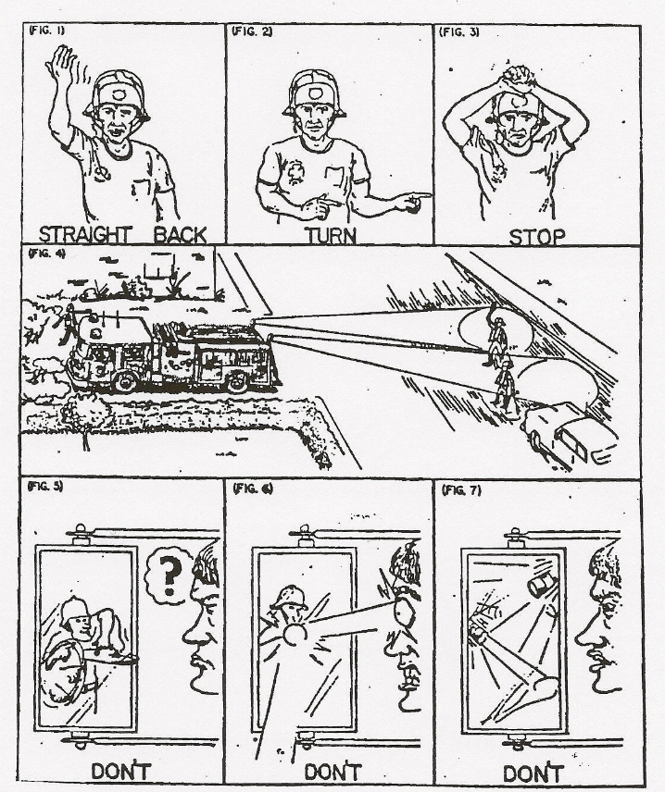

This is a sample guideline furnished to you by VFIS. Your organization should review this guideline and make the necessary modifications to meet your organization’s needs. The intent of this guideline is to assist you in reducing exposure to the risk of injury, harm or damage to personnel, property and the general public. For additional information on this topic, contact your VFIS Risk Control representative.

References:
West Redding (CT) VFD – GOG 10-OEV-1001 Developed/Revised/Reviewed by VFIS ETC

