REPLACE WITH YOUR MASTHEAD
 | SOG Title:
 | SOG Number:
 | Original Date: | Revision Date:

ABC Fire Department General Operating Guideline

Building Side/Quadrant/Exposure Designation System

This is a sample of a standard operating guideline (SOG) on this topic. You should review the content, modify as appropriate for your organization, have it reviewed by your leadership team and if appropriate your legal counsel. Once adopted, make sure the SOG is communicated to members, implemented and performance monitored for effective implementation.

Purpose:
This system has been established to uniformly identify particular building segments and exposures, which will allow companies to carry out these operating procedures in a coordinated manner.

Procedure:
Building Sides (refer to Figure 1)
- Side Alpha
  - This is normally the front or main entrance/access to the building and usually the side bearing the building address
  - For buildings with an unusual configuration, side Alpha will be identified by the first arriving unit, utilizing a suitable landmark (refer to Figure 2) such as the parking lot, swimming pool, boiler room, etc.
- Side Bravo is the left side of the building when facing side Alpha
- Side Charlie is the side opposite side Alpha
- Side Delta is the right side of the building when facing side Alpha

Building Wings (refer to Figure 2)
- Where configuration is such that sides cannot be easily identified, the building will be broken down into wings (see attachment drawings). Side Alpha will be the identified utilizing landmark. The remaining sides shall be identified by clockwise rotation similar to the above.

Quadrants (refer to Figure 1)
- The building interior shall be divided into quadrants A, B, C, and D starting at the left front of side Alpha A moving in a clockwise rotation
- The wings are to be broken down into quadrants when this will enhance safety and/or operations
- Floor numbers will identify building levels (refer to Figure 3)

Exposures
- Corresponds to sides of building, i.e. building on side Bravo is exposure Bravo

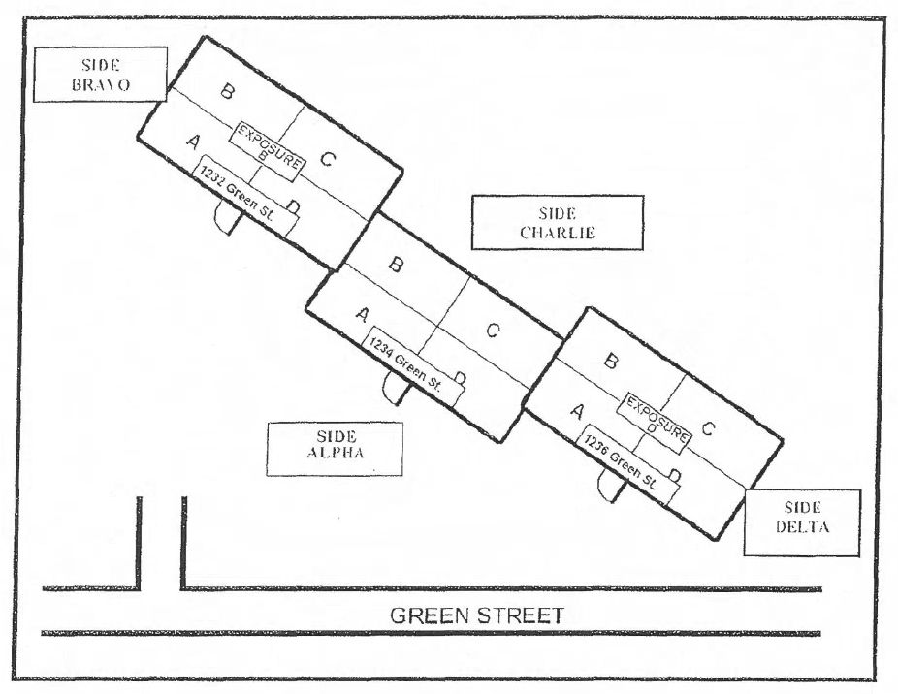

Figure 1: Side Alpha of the building shall be the side bearing the street address, or what is "normally considered the front" of the building. Sides Bravo, Charlie and Delta shall be determined by a clockwise rotation from Side Alpha 1. Exposures shall be designated by name, in the same manner as the sides. The building interior shall be divided in to quadrants, (A, B, C & D), starting at the left front of side 1 and moving in clockwise rotation. The levels shall be designated by floor number, and will be assigned Divisions.

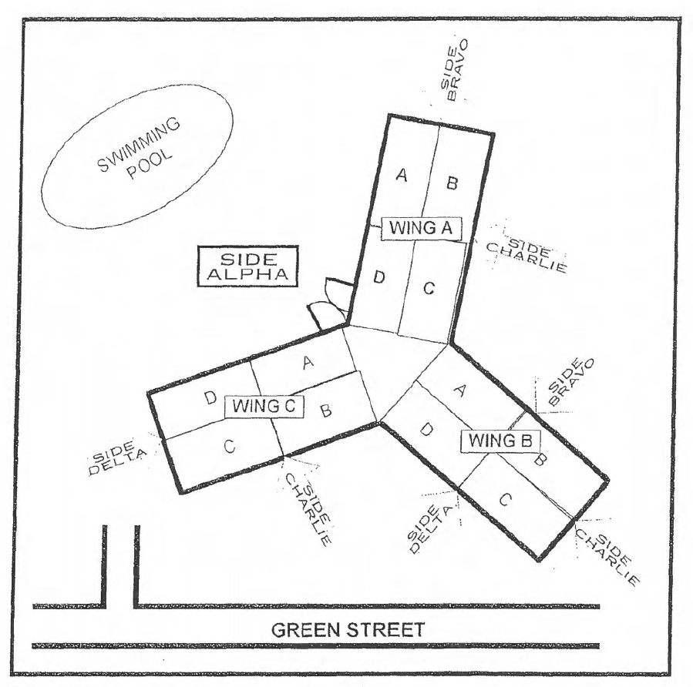

Figure 2: For buildings with an unusual configuration, side Alpha will be identified by the first arriving unit, utilizing a suitable landmark such as a swimming pool. Where configuration is such that sides cannot be easily identified, the building will be broken down into wings. Identify side Alpha utilizing appropriate land mark and designate wings by clockwise rotation starting with wing A. The building interior shall be divided into quadrants, (A, B, C, & D), starting at the left front side Alpha and moving in clockwise rotation. The levels shall be designated by floor number, and will be assigned Divisions.

Figure 3

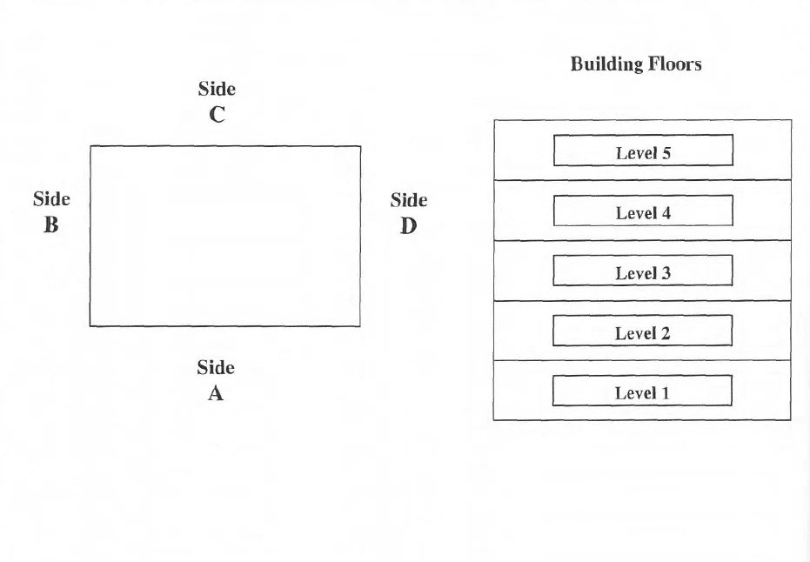

This is a sample guideline furnished to you by VFIS. Your organization should review this guideline and make the necessary modifications to meet your organization’s needs. The intent of this guideline is to assist you in reducing exposure to the risk of injury, harm or damage to personnel, property and the general public. For additional information on this topic, contact your VFIS Risk Control representative.

References:
Montgomery County (PA) Department of Public Safety Recommended Practice 2007-3

