REPLACE WITH YOUR MASTHEAD
 | SOG Title:
 | SOG Number:
 | Original Date: | Revision Date:

ABC Fire Department General Operating Guideline

Known Bomb Device

This is a sample of a standard operating guideline (SOG) on this topic. You should review the content, modify as appropriate for your organization, have it reviewed by your leadership team and if appropriate your legal counsel. Once adopted, make sure the SOG is communicated to members, implemented and performance monitored for effective implementation.

Purpose:
To provide an outline of operations, procedures and responsibilities when responding to a known or suspected explosive/bomb device.

Definitions:
A bomb threat is defined as the discovery of/or what may be suspected to be explosive material, military explosives, deteriorating ether and picric acid or other suspicious device or any event resulting in an explosion. Explosive material will include firework s and Molotov cocktails.

Scope:
It should be the responsibility of each firefighter to exercise the appropriate control dictated by his or her rank in the implementation of this procedure. Self-discipline is always the best discipline.

Bomb Scene Responsibility
- For the purpose of this procedure, a suspected object/device is the responsibility of local police and/or Sheriff s Department Bomb Disposal Unit unless and/or until a detonation occurs. Local police will Incident Command as part of the unified command process.
- Police procedure should be to notify the appropriate fire department after a device is discovered.
- Only certified hazardous device technicians from the bomb disposal unit should handle, deactivated, remove, examine or transport any found explosive material. Bomb disposal will make a determination regarding the method of disposal and the type of device.

Procedure:
Procedures When Device is Found, but not Detonated
- The fire division/branch should coordinate activities with the police incident commander. Hydrants close to the building should be avoided as blown glass can cause severe injury several hundred feet in all directions. The Incident Commander should designate a "STAGING AREA" (out of the potential hazard zone) to insure strict command and control of all personnel at the scene.
- The fire division/branch manager should designate a staging area, with the necessary equipment, outside the damage and injury perimeter, where all personnel are to report. A safe initial minimum distance is 500 feet. From here, orders would be issued and firefighters should return to this area upon completion of their assignments, thus giving the Fire Division better control.
- The staging area protects firefighters who are not involved in any other activity by keeping them in a safe remote area.
- Consider connecting engines to hydrants stretching water lines for service.
- Supply lines should be stretched and connected to standpipes and sprinklers where applicable.
- Fire personnel should be used to aid in evacuation of necessary areas as directed by police official in command. Consideration should be given to the stretching of appropriate water lines to the front and rear of the building. These lines should be utilized to protect the evacuation points should a detonation occur.
- Advance Life Support (ALS) units should be dispatched to the staging area before bomb technicians start their work.
- There should be no radio transmission and/or cellular phone use within 500 feet of the device.
- All protective clothing with face shields down should be worn by all personnel, including the pump operator.
- The Incident Commander should consider notifying the utility companies as to whether the utilities should be shut down prior to or after the incident.
NOTE: The following exception as per the bomb disposal unit is in effect: Firefighters may broadcast over fire radio or use cell phones under exigent/emergency conditions only when ALL of the following conditions are met:
- Firefighters and other personnel must be at least 500 feet from any suspect object/device before utilizing communication equipment.
- Firefighters and others must be under/behind hard cover (apparatus, building, wall, etc.)
- Members and others must never be in line of sight (direct distance with unobstructed view) of any suspect object/device. Remember - if you can see it - it can see you.

Weight and Distance Table:
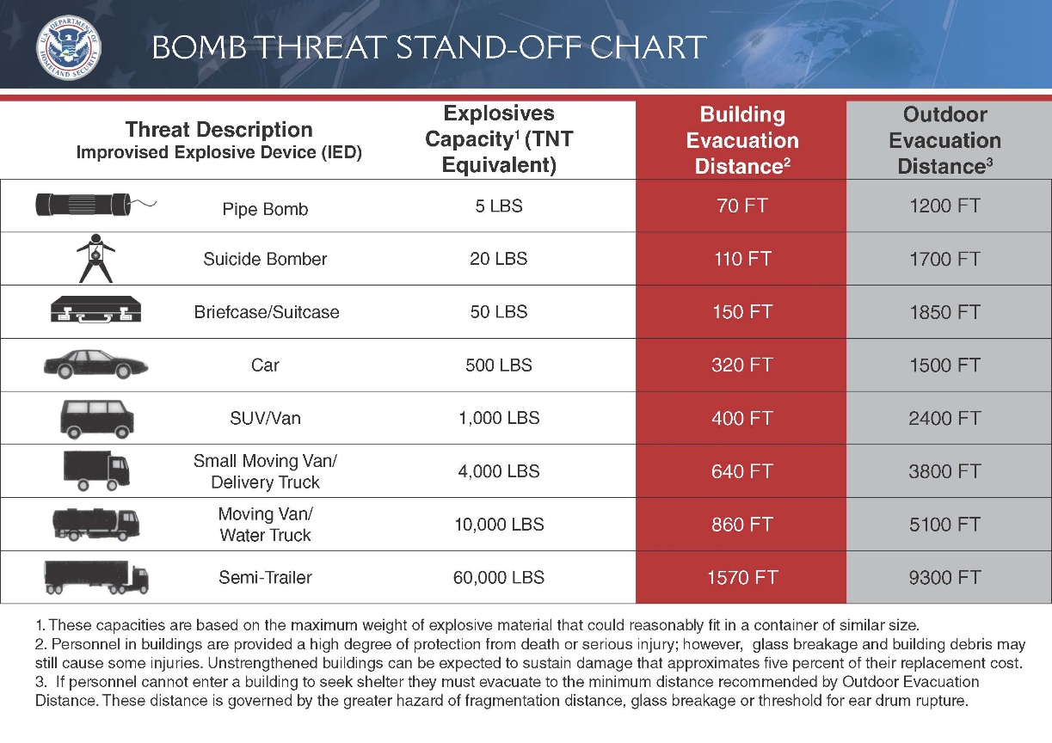
Source: www.hsdl.org
Procedure Where Device Has Detonated
- Firefighting and rescue operations should proceed, exercising extreme care as secondary explosions are a possibility. Protection of fire personnel should be of prime concern unless a life hazard is experienced.

Scene where Device is Discovered by Fire Department Personnel
- Move the apparatus out of the immediate area a minimum of 500 feet and notify Emergency Dispatch Services. This notification should be done via hard line phone, if at all possible. If the apparatus is at least 500 feet away from the incident then the Fire Radio can be used. Emergency Dispatch Services will, in turn, notify the appropriate Police Department and Bomb Disposal Unit.
- An immediate evacuation of the building and adjoining area should be carried out. It is generally assumed that the damage and serious injury perimeter will be approximately 500 feet.
- It must be remembered that bombs are designed to explode, and there is no positive way for the untrained to handle them safely. Never pick up or attempt to move any suspicious device. Many bombs are made in such a manner as to detonate in one of the following:
  - Cutting or untying a string can release and explode a primer.
  - Turning a cylindrical object can tilt or break a vial, thereby spilling a chemical mixture causing detonation.
  - Shaking a bomb can complete circuits when mercury switches are used.
  - Tearing a glued wrapper from a package may release the cover of a box and activate an electric current.
  - Unscrewing a cap when explosives may be adhered to threads.

EXPLOSIVE POST-BLAST RESPONSE
Post-blast (or post-detonation) response takes place after an explosion has occurred. An explosives event has the potential to overwhelm first responders due to the large number of victims, fatalities and property destruction.

Dispatch and Response Phase
- When responding get all the dispatch information available. Nature of the call and location are important.

Arrival on Scene
- Proceed with extreme caution for your own safety.
- Slow down when approaching the area and conduct a 360-degree scan during your scene size-up or "windshield survey".
- Look for objects and people that seem out of place for the location or time of the call - if it looks suspicious it probably is.
- Use Staging Area to limit number of responders - don't stack up responders and resources in one location.
- Avoid entering blast areas (Hot Zone) unless it is necessary to save lives.
- ALWAYS BE AWARE OF SECONDARY DEVICES

Approaching the Area
- Always have an escape route open to leave the scene quickly if needed. Apparatus can be backed into scene to ensure a quick egress.
- All responders should wear all available Personal Protective Equipment (PPE).
- Appropriate agencies - Fire, EMS, law enforcement, specialized bomb personnel, emergency management, and hospital s should be notified as soon as possible if there is a report of an incident or possible incident.
- If multiple casualties, request County DPS Mass Casualty Plan activation.
- BE VERY CAUTIOUS OF ANY ITEMS THAT AROUSE YOUR CURIOSITY

Response Operations
- An explosives incident has the potential for a large number of victims with very traumatic injuries.
- Searching beyond the immediate scene for victims unable to call for help. This may be needed in a dense urban environment, where persons in upper stories of a building were injured/affected, directly by the attack, or anyone suffering a health condition.
- Some seriously injured victims may have no visible wounds and some victims may be beyond help.
- Quickly remove victims from the area and render aid in a secure location. Triage should be conducted outside the hazard area.
- Implement mass casualty/mass fatality procedures.
- Responders should immediately monitor for other hazards such as chemical agents, gases or radioactive materials. Decon may be needed.
- Be aware of secondary hazards such as unstable structures, damaged utilities, hanging debris, void spaces and other physical hazards.
- Consider the need for other assets such as Urban Search and Rescue, Hazardous Materials Teams, Incident Management Teams, etc.
- Be aware of the possibility of secondary devices and attacks. This type of event has targeted responders.

Crime Scene Considerations
- Establish as large a crime scene perimeter as possible. Rule of thumb for the perimeter is to extend the perimeter 50% from the farthest piece of evidence located.
- Plan on an intensive media response. Establish Joint Information Center (JIC).
- Make immediate notifications of local, state and federal resources.
- Plan on an extensive, multi-day crime scene investigation.

This is a sample guideline furnished to you by VFIS. Your organization should review this guideline and make the necessary modifications to meet your organization’s needs. The intent of this guideline is to assist you in reducing exposure to the risk of injury, harm or damage to personnel, property and the general public. For additional information on this topic, contact your VFIS Risk Control representative.

References:
Montgomery County Department of Public Safety Recommended Practice 2009-3
Department of Homeland Security

