REPLACE WITH YOUR MASTHEAD
 | SOG Title:
 | SOG Number:
 | Original Date: | Revision Date:

ABC Fire Department General Operating Guideline

Personal Vehicle Safety Checklist

This is a sample of a standard operating guideline (SOG) on this topic. You should review the content, modify as appropriate for your organization, have it reviewed by your leadership team and if appropriate your legal counsel. Once adopted, make sure the SOG is communicated to members, implemented and performance monitored for effective implementation.

Purpose:
This safety checklist is provided for you to conduct a basic safety survey of your organization’s members’ personally owned vehicles. This is not intended to be a mechanical inspection and is not a substitute for one.

Procedure:
This checklist reviews some of the basic components that should be well maintained to provide a vehicle that is in safe working order. Anyone with basic knowledge of a vehicle’s operating components should be able to conduct the survey. This survey should be completed on an annual basis.

Required Documents: Verify that listed documents are present, current, and appropriate.
Tires: Tires should be checked to determine if there are any obvious conditions that would make them unsafe, e.g., cuts, bulges, uneven tread wear, questionable inflation level and inadequate tread depth. Tires should generally be of the same size and style. Any questionable items should be evaluated and repaired by a qualified automotive technician.

Lights: All lights should be checked to determine if they operate properly, have the proper lens covering, are clearly visible, and are properly adjusted. Any questionable items should be evaluated and repaired by a qualified automotive technician.

Body: The body of the vehicle should be checked to determine that all required components are on the vehicle e.g. fenders, hood, bumpers, etc. Any damaged component should be checked to determine if it will interfere with the safe operation of the vehicle or present a safety hazard for pedestrians or other vehicles.

The exhaust system should be checked to determine if it is operating properly. Visually check to determine if all parts are present and that they are safely attached to the vehicle. Operationally, the exhaust system may be checked by briefly holding a pliable object (such as a rag) over the end of the exhaust pipe to obstruct the flow of exhaust. If back pressure is felt on the object while it is held in place and no hissing or whistling is heard in other parts of the exhaust system, it is reasonable to assume that the exhaust system is working. However if little or no pressure is felt on the object blocking the exhaust pipe and/or exhaust gases can be heard escaping from other parts of the system, the vehicle should be further examined by a qualified technician. Caution should be used when checking exhaust systems, as exhaust gases and the system components may be very hot and can cause injury.

Glass: All glass should be checked to determine if it is in good condition, free of chips, cracks, and breaks. Windows should also be free of obstructions that would inhibit the driver’s ability to see out of the vehicle when driving. Door windows should be operational, in particular the driver’s door.

Accessories: Windshield wipers should be checked to determine if they are functional. The blades themselves should be in good condition, free of loose or missing blade surface. The vehicle’s washer system should also be tested to determine if it is functional.

Approved warning/courtesy lights should be checked to determine if they are properly installed and operational. The vehicle operator should have the proper permits and documentation for the warning/courtesy lights.

Repairs Needed: This section should be completed for any item that is suspect or in need of replacement or repair. The section should be torn off and given to the vehicle owner/operator to take to the appropriate qualified party for inspection, replacement, or repair. Upon successful completion this section, along with a work order/repair bill, should be returned to the organization as proof that the hazardous condition has been eliminated. Discretion should be used by the organization as to whether an observed condition would warrant prohibiting the vehicle’s use in conjunction with the emergency service organization until the repair and/or replacement is made.

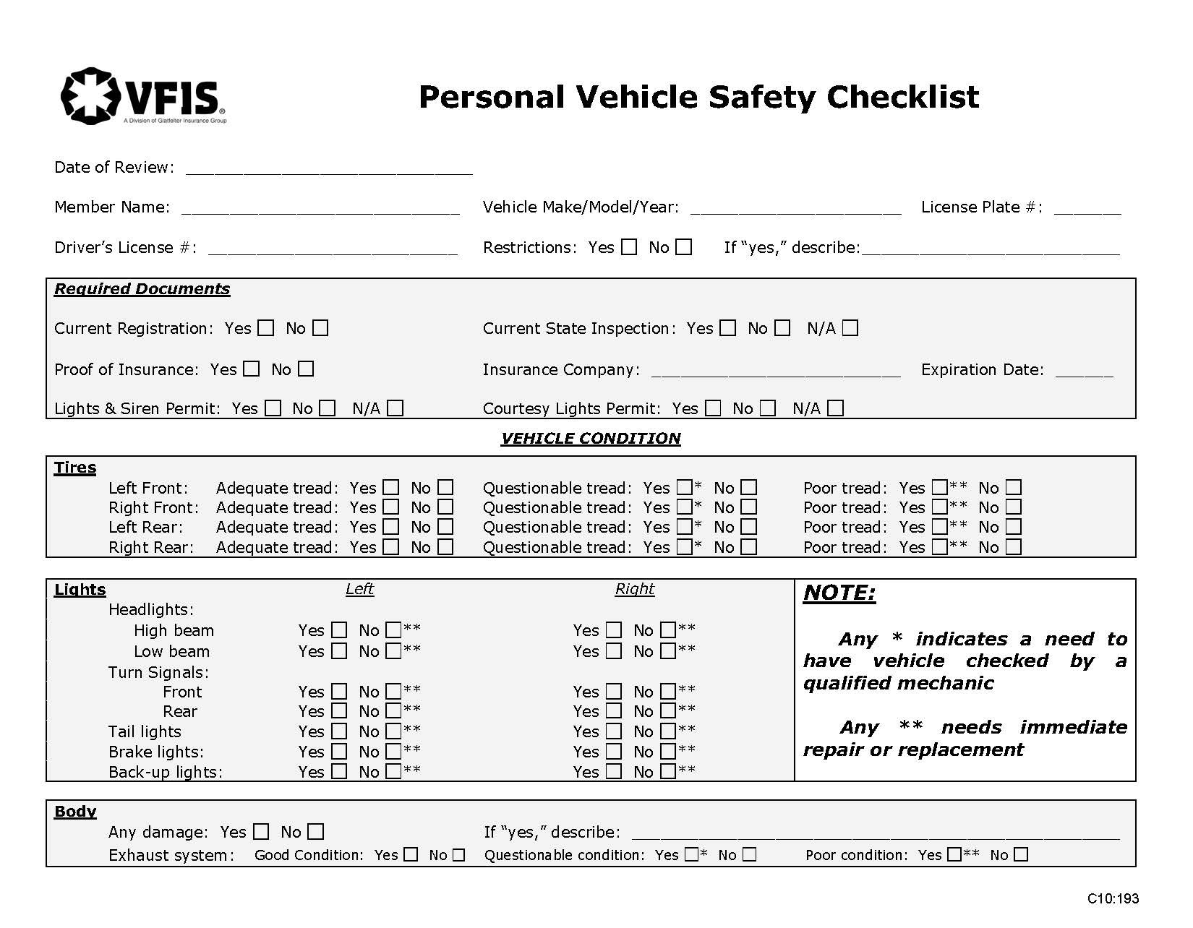
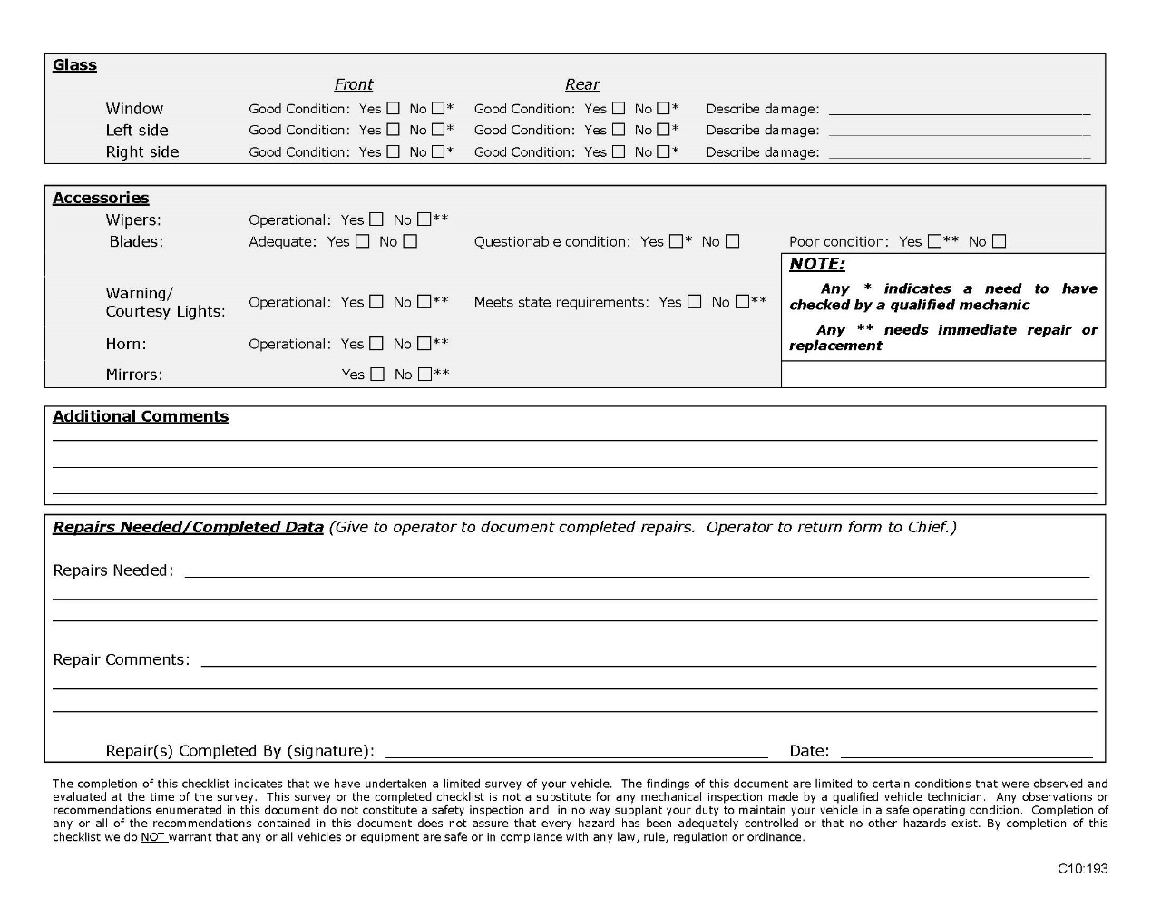

This is a sample guideline furnished to you by VFIS. Your organization should review this guideline and make the necessary modifications to meet your organization’s needs. The intent of this guideline is to assist you in reducing exposure to the risk of injury, harm or damage to personnel, property and the general public. For additional information on this topic, contact your VFIS Risk Control representative.

References:
VFIS Risk Communique – “Personal Vehicle Safety Checklist”

